1. Removed from eBcode the externals

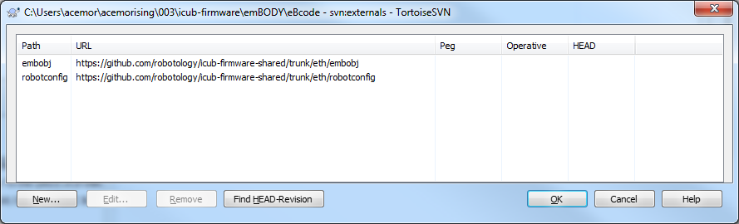

1. Changed the projects so that they used directly icub-firmware-shared

changes due to removal of external from icub-firmware-shared

in arch-arm\board\

was: ..\..\..\..\..\..\robotconfig

is: ..\..\..\..\..\..\..\..\..\icub-firmware-shared\eth\robotconfig

was: ..\..\..\..\..\..\embobj

is: ..\..\..\..\..\..\..\..\..\icub-firmware-shared\eth\embobj

was: ..\..\..\..\..\..\..\..\canProtocolLib

is: ..\..\..\..\..\..\..\..\..\icub-firmware-shared\can\canProtocolLib

in eBtest

was: ..\..\..\..\..\..\..\eBcode\robotconfig

is: ..\..\..\..\..\..\..\..\..\icub-firmware-shared\eth\robotconfig

was: ..\..\..\..\..\..\..\eBcode\embobj

is: ..\..\..\..\..\..\..\..\..\icub-firmware-shared\eth\embobj

was: ..\..\..\..\..\..\..\..\canProtocolLib

is: ..\..\..\..\..\..\..\..\..\icub-firmware-shared\can\canProtocolLib

1. Haven’t removed the external of canProtocolLib yet.